

**Automated Poultry Light and Feed Management System: Low-Cost Solution: Case study of Twapia Community**

**STUDENT ID: 1703012**

**STUDENT NAME: Makoba Ngulube**

**YEAR: 2023**

**Declaration**

I Makoba Ngulube of ID 1703012 declare that the submitted Research Proposal is my original work and no part of it has been published anywhere else in the past and has not been conducted after the registration for the degree at Northrise University or previously included in a thesis or dissertation submitted to this or any other institution for any qualification. I have understood the University’s current research ethical guidelines, procedure and standards and accept the responsibility for the conduct of the procedures in accordance with the Student Hand. I have endeavored to identify all the risks that may arise in conducting this research, obtained the relevant topic approval, ethical clearance and acknowledged my obligations and the rights of the participants.

Signed: …………………………………………….

Date: …………………/……. /…………………….

**Abstract**

Poultry is a very delicate type of bird and as such requires the best type of management style. Some of the existing manual management styles are outdated and usually manual as well as inaccurate (Bhattarai, 2019). One way of tackling this issue can be the implementation of automated poultry management system model. One down side of the existing management systems available is how inaccurate they are due to the fact they usually focus on one factor as opposed to the others. An example of this is how some management systems focus only on temperature and neglect the other environmental parameters that can affect poultry. With these downsides came the inspiration to conducted my research on poultry and the title of my research proposal was “Automated monitoring system for poultry using IoT (Internet of Things): Twapia community”. The main question that was to be answered in this proposal and research was “How can the integration of a low cost automated light and feeding monitoring system model help to provide the adequate amount of lighting as well as improved feeding efficiency and benefit the poultry farmer?” The main purpose of this research was to create a low cost automated poultry management system that is to benefit the low income farmer to manage the environmental conditions of the poultry environment in real-time as well as resolve any abnormalities that may have incurred within the poultry in real-time. It also aimed to give feedback of the conditions of the poultry in real-time to the authorized user of the system model. It aimed to do this taking into account factors that other systems had missed out on like lighting, and feeding etc. The main population target of this research was the low income poultry farmers of Twapia as these were the targets that the model was being developed. For this research, I used the convenience sampling technique as it was inexpensive and the best option for student researchers. I also resorted to using this sampling technique as it provided the participants opinions at the convenience of the participants. As for the data collection, I utilized questionnaires since they allowed me to deliver information at the interviewees' convenience in some events where they were not available for interviews on that particular day or at the particular time that I hoped to have an interview. Observations were also carried out in order for the model to be developed model to as accurately as possible replicate what was seen during this observation time. As for the data analysis, I utilized the qualitative data analysis technique for my study since it aided in the examination of documented material in any form it may take.

**Table of Contents**

Contents

Chapter 1: Introduction 4

Background Information 4

Statement of the Problem 6

Research Question and Hypothesis 6

Purpose Statement 6

Significance of the Study 7

Research Method 8

Research Design 8

Population 8

Sample 9

Assumptions 9

Limitations 9

Delimitations are choices made by the researcher which should be mentioned 10

Ethical Considerations 10

Timeline 11

Definitions 11

Chapter 2 – Literature Review and Conceptual/Theoretical Framework 11

Conceptual/Theoretical Framework 11

Review of existing related literature 12

Chapter 3: Sampling Method 15

Sampling Method 15

Data 16

Data Collection and Recording 16

Data Analysis 17

References 20

# 

# Chapter 1: Introduction

## **Background Information**

Poultry farmers have been facing a high mortality rate of poultry due to mortality rate of poultry some of which include temperature, humidity, feeding, etc. due to the manual methods of monitoring their birds, such as using manually controlled lighting with bulbs and manually feeding poultry. According to Ayssiwede et al. (2021), poor lighting can lead to a decrease in egg production in poultry. The continued use of manual bulbs to control the amount of lighting has proved difficult to control and expensive for the poultry farmer because of the continued use of manual labor to monitor the amounts of light within the poultry. . The system model was also able to remotely control the environment by adjusting the feeding, and lighting. The study found that lighting management was a key factor in improving the growth and productivity of poultry and that adding this feature to future systems could further improve the system's efficiency. To address these issues, an automated poultry management system will be developed using IoT. The model aims to reduce the mortality rate of poultry by ensuring that supplemented with the proper amounts of feed needed, as well as improve the production of eggs among chickens by supplementing them with the adequate amount of lighting required. Another aim of this system is to be of low cost as it will be mainly for the low cost farmers and as such will use low cost components for its implementation. In the event of an abnormality such as abnormal temperatures, humidity, or lighting, the automated model will implement real-time resolutions automatically. The model’s other aim is to lower the cost incurred by farmers to manually monitor their poultry with traditional methods like having someone physically feed the poultry or manual bulbs for lighting. The system will make well-informed decisions on the appropriate actions to take based on data read by sensors to make the poultry environment as conducive as possible. The system also aims to produce a good breed of poultry that has been subjected to the best conditions, which is beneficial to farmers as their poultry can fetch higher prices on the market. Several studies have been conducted on the use of automated management systems in poultry farming. Another study by Tanyildizi et al. (2019) showed that automated management systems can improve poultry welfare by reducing stress and improving growth rates.

# Statement of the Problem

The improper manual control of lighting, feeding in poultry farming has been noted to result in reduced productivity, high cost on farmers and increased mortality rates among poultry. Another factor that has led to the continued use of manual systems by small scale farmers is the high cost it takes to implement these systems into their poultries (Halidou, 2020). According to Mishra and Behl (2019), manual feeding resulted in inconsistent feeding, which led to higher mortality rates in broilers compared to automated feeding systems. According to Ayssiwede et al. (2021) manual control of lighting has been known to negatively affect the reproductive systems of chickens and lead to reduced egg production. The current lack of automated management systems in poultry farming has led to high labor costs for farmers who have to pay workers to constantly monitor the poultry (Oloyo & Adedamola, 2019). The traditional methods used for maintaining proper feeding and lighting levels using manual labor have proven to be inaccurate and unreliable. A solution to helping solve these problems is the creation of an automated management system model that will be able to regulate the amount of feeding and lighting within the poultry to help with the reduction of mortality rate by factors associated to inconsistent feeding factors Olanrewaju et al. (2019) and the system will also be able to handle lighting related problems that deal with the inconsistent amount of lighting within the poultry. The system will be able to always allocate the adequate amount of lighting within the poultry automatically.

## **Purpose Statement**

The goal of this research is to create an Automated Poultry Management System that is based on IOT to help assist with the lowering costs that farmers incur from manual methods of monitoring poultry, reduce mortality rate by monitoring the poultry feeding and improve egg production by always supplementing the poultry with the adequate amounts of lighting. The objectives of this research were to:

1. Improve mortality rates by supplementing chickens with the proper amounts of feed always and improve the lighting in the poultry by always supplementing the poultry with the proper amounts of lighting with the implementation of an automated poultry management system model.
2. bring in an automated management system that is to be more cost effective and efficient as opposed to manual monitoring methods and other more expensive poultry management systems.
3. Reducing the running cost of running poultry.

**Research Question and Hypothesis**

My research was guided by the following research questions:

1. How effective is an automated management system in controlling lighting, feeding, and improving the labor cost on farmers in poultry farming, and how does it compare to manual management methods?
2. What is the impact of an automated management system model on poultry productivity?
3. What are the economic benefits of using an automated management system in poultry farming, such as reductions in labor costs and improvements in product quality?

## **Significance of the Study**

The increased demand for poultry has forced many poultry farmers to find better ways of keeping their poultry to meet the demand. To meet these demands many poultry farmers have resorted to automated management systems that can help them better monitor their poultry (Aldosari, 2021). The proposed system will greatly contribute to the poultry farmers as it will allow them to tackle certain challenges that come with raising poultry like mortality rate that is among many factors caused by improper feeding, improved egg production which is among many other factors caused by poor/improper lighting. According to Zou et al. (2020), the use of automated monitoring systems in poultry farming can lead to increased productivity and efficiency, resulting in increased customer demand as well as reduced labor costs. The main targets for this model are the small scale poultry farmers of Twapia who are still using traditional methods of managing their poultry. According to Alabi et al. (2021), the use of automated management systems in poultry farming can significantly reduce labor costs.

**Deliverables**

This part of the document outlines the deliverables of the research project which is an automated poultry management model which will be used by low income poultry farmers to enhance poultry egg production, reduce mortality rate and reduce running cost of the poultry. The system will be managing and regulating the internal lighting of the poultry with the aid of sensors that will be placed inside the poultry. it will control the lighting and duration of the lighting to suit the needs of the poultry automatically. The system will also manage the feeding of the poultry automatically which will reduce/eliminate mortality rate as well as the need for manual labor. As a result of this, there will be reduced need for manual labor which will in turn lower the cost of the day to day costs that would previously be done over a long period of time.

**Timeline**

The research timeline for this project is 16 weeks as set by the Northrise University board.

**Definitions**

**IOT -** The internet of things, or IoT, is an interconnected network of computing devices, mechanical and digital technology, products, vehicles, and humans with unique identifiers and the ability to transfer data without requiring human-to-human or human-to-computer interaction (Igbafe, 2018).

**WSN**: A wireless sensor network is a collection of specialized sensors linked by a communications network to monitor and record conditions in several locations (Niranjan, 2018). Some of the most regularly monitored characteristics include temperature, humidity, pressure, wind speed and direction, power-line voltage, chemical concentrations, pollution levels, and vital physiological functions.

**Arduino and Arduino kits**– an Arduino is an open-source electronics platform based on simple hardware and software. It consists of a circuit board, which can be programmed and connected to sensors, actuators, and other devices to create interactive projects. The Arduino platform is designed for artists, designers, hobbyists, and anyone interested in creating interactive objects or environments (Arduino, n.d.).

**Conclusion**

In this chapter, the background information for the research proposal was outlined following the extent to which previous researchers focused. The motivation, significance and scope for the intended project was also outlined. In addition, the problem statement, objectives and research contributions have been given. The next chapter will focus on reviewed scholarly literature for the intended research project, and will outline a theoretical framework that will guide this project.

## 

# Chapter 2 – Literature Review and Conceptual/Theoretical Framework

## 

## **Review of existing related literature**

A poultry environment is a very delicate housing for poultry which in this aspect refers to chickens, and to get the best out of the poultry environment, management is done to ensure that the poultry within the poultry are subjected to the best conditions (Gonzalez, 2021) .the internet of things (IOT) plays a very vital role in monitoring of poultry environments as the real time systems make it possible for the monitoring to happen in real time be it feeding, vaccination schedules, death, temperature, humidity and many other poultry environmental factors. In this chapter of the document, a summarization of the read literature will be taken into account as well as the potential area of future research as per the read literature that inspired this research. The main significance of this research is to create a low cost automated management system model that will reduce the mortality rate of poultry by supplementing the poultry with the adequate amounts of feed, maintain the adequate amounts of lighting in the poultry and reduce the running costs of labor on the poultry farms.

**Literature review**

**Manual Poultry Feeding and Mortality**

A review of the literature shows that manual poultry feeding is a common practice in many small-scale poultry operations. However, studies have shown that this feeding method can lead to higher mortality rates in poultry. For instance, a study by Elwinger and Tauson (1997) found that birds fed manually had a higher mortality rate compared to those fed using automatic feeders. Similarly, a study by Kitalyi (1998) found that manual feeding was associated with increased mortality rates due to issues such as overfeeding and uneven distribution of feed. Another study by Chauhan et al. (2015) found that manual feeding led to stress and aggression among birds, which in turn increased mortality rates.

**Automation of Poultry Feeding and Mortality**

A review of the literature shows that automated feeding systems have the potential to reduce mortality rates in poultry. A study by Cao et al. (2020) found that an automatic feeding system improved the feed efficiency and growth rate of broilers, leading to a lower mortality rate. Similarly, a study by Kozlowski et al. (2021) found that an automatic feeding system reduced the incidence of cannibalism and pecking, leading to lower mortality rates in laying hens. Another study by Alim et al. (2019) found that automated feeding systems reduced the incidence of feed wastage and contamination, leading to a lower mortality rate.

**The impact of manual poultry feeding on poultry mortality and the potential benefits of automated feeding systems**

This literature review explores the impact of manual poultry feeding on poultry mortality rates and the potential benefits of automated feeding systems. Manual feeding can lead to inconsistent feeding, overfeeding or underfeeding, which can cause digestive problems, diseases, and infections in birds. Moreover, manual feeding can cause stress among birds, leading to poor growth and increased mortality rates. In contrast, automated feeding systems provide consistent and accurate feed distribution to birds, improving feed efficiency and reducing stress levels, resulting in improved growth and reduced mortality rates. Additionally, automated feeding systems can reduce labor costs, improve operational efficiency, and enhance food safety and quality control. Further research is necessary to evaluate the impact of automation technologies on the poultry industry's sustainability and the development of intelligent feeding systems that can monitor bird behavior and adapt feed distribution to individual needs. (References: Rabelo et al., 2019; Ganaie et al., 2020; Aruna et al., 2019; Lilburn, 2019; Olawumi et al., 2020; Havenstein et al., 2020)

**Effects of light on the growth, behavior and welfare of broiler chickens**

This article reviewed the effects of light on broiler chickens, focusing on growth, behavior, and welfare. The authors noted that light intensity and duration can have significant effects on broiler growth and that providing longer photoperiods could increase feed intake and weight gain. Additionally, the review highlighted the importance of providing adequate lighting for behavioral needs, such as promoting activity and reducing fearfulness. The authors suggested that future research could focus on optimizing lighting schedules to balance growth and welfare needs (Sánchez-López et al., 2020).

**Artificial lighting for laying hens in a commercial poultry farm**

This study investigated the effects of artificial lighting on laying hens in a commercial poultry farm. The authors found that hens exposed to long-day lighting had improved egg production and shell quality compared to those on short-day lighting. Additionally, they noted that providing night-time dim lighting reduced aggressive behavior and improved welfare. The authors suggested that future research could explore the effects of different light spectra on laying hen welfare and productivity (Bueno-Guerra et al., 2019).

**Light-emitting diodes for poultry lighting: a review**

This review focused on the use of light-emitting diodes (LEDs) in poultry lighting. The authors noted that LEDs have several advantages over traditional lighting, such as energy efficiency and the ability to customize light spectra. They also highlighted the potential for LEDs to improve broiler growth and welfare by providing optimal light intensities and durations. However, the authors noted that further research is needed to determine the optimal light spectra for different poultry types and ages (Nascimento et al., 2020).

**The effects of light color on poultry welfare and productivity: a review**

This article reviewed the effects of different light colors on poultry welfare and productivity. The authors found that blue light can improve broiler growth and red light can increase egg production in laying hens. However, they noted that excessive blue light exposure can cause negative welfare effects, such as eye damage and stress. The authors suggested that future research could investigate the effects of different light colors on the welfare and productivity of different poultry types and ages (Riber and Guzman, 2019).

**Light pollution in broiler houses: a review**

This review focused on the effects of light pollution on broiler chickens. The authors noted that excessive light exposure can disrupt circadian rhythms and cause negative welfare effects, such as reduced immune function and increased mortality. Additionally, they highlighted the potential for light pollution to increase energy consumption and environmental impact. The authors suggested that future research could investigate the effects of different lighting schedules and intensities on broiler welfare and productivity while minimizing light pollution (Gregory and Clench, 2020).

**The influence of light on the behavior and welfare of broiler chickens**

This study investigated the effects of different light intensities on the behavior and welfare of broiler chickens. The authors found that moderate light intensities improved activity levels and reduced fearfulness compared to low or high intensities. Additionally, they noted that providing natural light or mimicking natural lighting conditions improved welfare and reduced stress. The authors suggested that future research could investigate the effects of different lighting schedules and intensities on the welfare and productivity of different poultry types and ages (Koenen et al., 2020).

**"Light intensity and wavelength affect broiler growth performance and welfare: a review"** This review focused on the effects of light intensity and wavelength on broiler growth performance and welfare. The authors found that providing higher light intensities increased broiler growth and that blue light improved feed conversion compared to red or green light. However, they noted that excessive light exposure can cause negative welfare

**Challenges with current systems**

After reviewing various literature on lighting in poultry farming, it has become evident that there are several challenges with the current poultry systems. One common issue is the lack of standardization in lighting regimes, which has been found to impact egg production (Hocking et al., 2020). Other challenges include the difficulty in monitoring light intensity and duration in poultry houses, which can lead to inadequate lighting and reduced egg production (Al-Zahrani et al., 2021). Additionally, inconsistent lighting regimes can cause stress to the birds and result in a decline in egg production (Pishnamazi et al., 2018). To address these challenges, researchers have proposed several potential areas of future research. One solution is to incorporate automated lighting control systems, which can adjust lighting intensity and duration based on the needs of the birds (Karunathilake et al., 2020). Another potential solution is to improve the accuracy of light management systems, such as by using advanced sensors and software to track light levels in real-time (Liu et al., 2021). Additionally, there is a need to standardize lighting regimes to ensure that all birds receive consistent and the adequate amounts of lighting, which can help reduce stress and improve egg production (Kopsidis et al., 2022). By implementing these solutions, it is possible to improve the accuracy and reliability of poultry management systems, which can lead to increased egg production. Automated lighting control systems can ensure that birds receive the optimal amount of light, leading to better health and productivity (Karunathilake et al., 2020). Improved light management systems can help farmers detect and address any issues with lighting, further improving the productivity of the birds (Liu et al., 2021). Standardized lighting regimes can help reduce stress on the birds, leading to improved egg production and quality (Kopsidis et al., 2022). In addition to the lighting, a good addition to the automated management system would be to include automated feeding of poultry which would help reduce the mortality of poultry by factors related to feeding (Lilburn, 2019). The inclusion of the automation feeding management would also help to reduce the labor costs incurred on farmers from the manual methods that are currently being used for the feeding (Akinola, 2021).

Top of Form

In conclusion, implementing the strategies proposed by Nazir et al. (2021), Zhang et al. (2020), and Samiullah et al. (2020) can potentially improve mortality rate in poultry and reduce labor costs incurred by farmers. However, further research is needed to determine the effectiveness and practicality of these strategies in different poultry farming settings.

**Theoretical Framework**

In any research endeavor, a framework provides a crucial foundation upon which the study is built. It provides a structure that guides the researcher in identifying the variables, their relationships and the underlying theories that inform the study. A framework is essential in ensuring that the research is well designed, rigorous, and credible. It also helps to ensure that the study is relevant and applicable to the real world problems that is seeks to address. With that said, for this research study, the best method would be a qualitative research method. Qualitative research focuses on understanding and interpreting social phenomena by exploring and describing people's experiences, attitudes, and behaviors through open-ended questions and observations (Creswell, 2014). The proposed research study aims to understand the experiences of poultry farmers with automated monitoring systems and how it has impacted their poultry productivity and reduced their costs. Therefore, a qualitative research method would be appropriate to gather in-depth insights from the participants on their experiences and perspectives on the use of automated monitoring systems in poultry farming.

The research design that best suits this qualitative research method is a phenomenological design. The phenomenological design is concerned with exploring and describing the essence of human experiences related to a particular phenomenon (Creswell, 2014). This design will help us to understand the experiences of poultry farmers with automated monitoring systems, how they perceive it, and what impact it has on their poultry productivity.

The theoretical framework that will be used for this research study is the Technology Acceptance Model (TAM). The TAM model is a widely accepted theory that explains user acceptance and adoption of technology (Davis, 1989). This model will help us understand the factors that influence the acceptance and adoption of automated monitoring systems among poultry farmers. It posits that perceived usefulness, perceived ease of use, and attitude towards technology are the critical factors that determine user acceptance and adoption of technology (Davis, 1989).

Therefore, the TAM model is appropriate for this study as it will provide a theoretical framework to understand the factors that influence the adoption of automated monitoring systems among poultry farmers. It will also help us understand how the perceived usefulness, perceived ease of use, and attitude towards technology have an impact on the acceptance and adoption of automated monitoring systems among poultry farmers.

**Conclusion**

With the implementation of systems that tackle factors to reduce mortality rate, and poor lighting for poultry as well as running costs, farmers will be more likely to experience higher and better yields of poultry as they will be in an environment that will always favor their (poultry) growth and production. The farmers are to also see a reduction in the cost of running the poultry business.

## 

## **Chapter 3 - Research Methodology**

For this research, I will use the case study approach of Twapia community to understand the workings of the poultry and the appropriate measures to take into consideration and implement the findings from the interviews into the to be developed system. The main reason for the use of case study design is that they help to investigate real-world issues (Pandey, 2019). The main purpose of this research is to develop an automated monitoring system model that will monitor environmental conditions of the poultry like the lighting as well as the temperature of the poultry. This research is fueled with the aim of answering the question “Can the implementation of automated systems reduce mortality rate, reduce labor costs and improve egg production of poultry?”.

A research methodology is a way in which a research problem can be solved systematically. It objectives is to provide researchers with focus and appropriate approaches that they can use to tackle at hand issues (Wixom, 2018).

**Project Design**

the proposed system of this research will be a model that will be used to by farmers to monitor the conditions of the poultry namely the temperature of the poultry, the lighting as well as help to reduce the labor cost that is incurred on farmers to manually monitor the aforementioned poultry conditions. The final deliverable of this research is a system that will be installed within a poultry model house with the aim/objective of monitoring the temperature and the lighting of the poultry model. To help the farmer understand the happenings of the system, an interface will be created to which the famer can use to monitor the systems performance at attempting to provide the appropriate regulations within the poultry. The system will provide real-time feedback on any abnormalities that may result within the poultry. It will also provide real-time feedback on how it is controlling the situation within the poultry through the aforementioned interface. The data that will be collected will be used to help the system make the appropriate decisions based on the readings from the sensors.

**Project procedure**

in this section of the research document, some of the components that will be used in the creation of the system will be documented. This section will also include some of the programming languages that will be used in the creation and connection of the components that will be used within the system.

**Arduino board**

The Arduino board is a microcontroller that forms the core of the lighting and feeding system. It receives input from sensors and switches and uses this input to control the lighting and feeding mechanisms.

**Figure 1.**

*Image of arduino board*

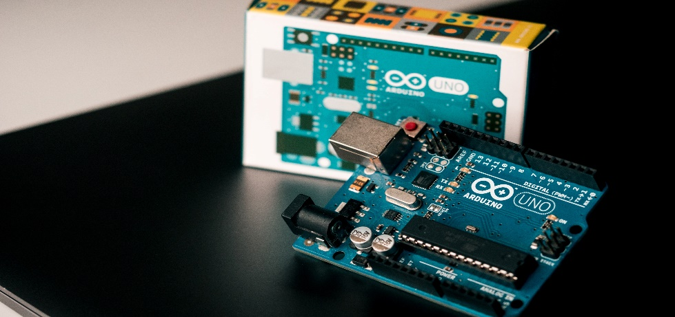

**Light sensor**

A light sensor is used to measure the amount of light in the poultry house. This is important because poultry require a certain amount of light to stimulate feeding and growth. A common type of light sensor used in Arduino projects is the photo resistor

**Figure 2.**

*Image of light sensor*

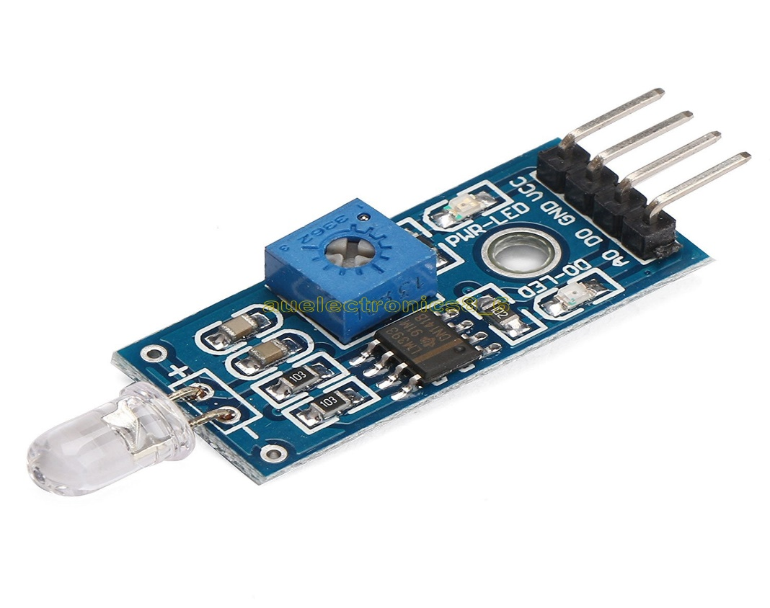

**Feeder**

The feeder is the mechanism that distributes food to the poultry. It can be controlled by the Arduino board using a motor or servo.

**Figure 3.**

*Image of feeder*

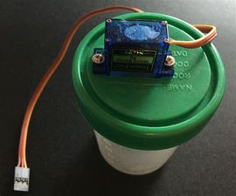

**Motor or servo**

The motor or servo is used to control the feeder mechanism. It receives instructions from the Arduino board and moves the feeder accordingly.

**Figure 4.**

*Image of servo motor*

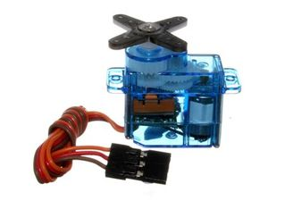

**RTC module**

The RTC (Real Time Clock) module is used to keep track of time and date in the system. This is important for scheduling the feeding and lighting cycles for the poultry.

**Figure 5.**

*Image of RTC module*

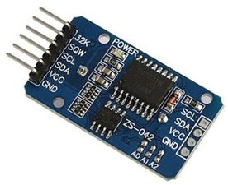

**LED lights**

LED lights are used to provide the necessary lighting for the poultry. They can be controlled by the Arduino board using a relay module.

**Figure 6.**

*Image of LED lights*

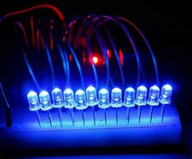

**Relay module**

The relay module is an electronic switch that can control high voltage and current loads. It is used to connect the Arduino to the LED lights and switch them on or off.

**Figure 7.**

*Image of Relay Module*

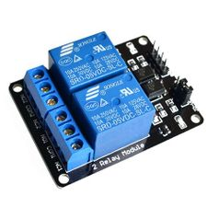

***LCD (Liquid Crystal Display)***

A Liquid Crystal Display will be used to view the happenings of the system in real-time. The LCD can be used to view readings, text, for connected devices like the data readings from the DHT11 sensor module or ESP32 readings in real-time (Jobit, 2019). The readings are displayed from the module via a 16*2 grid of which the 16 represents the number of columns and the 2 representing the number of rows which means you can to sets of text each displaying 16 characters in the 2 available columns. This screen will be used to display the readings in the event that the interface is not available or temporarily down or under maintenance.

**Figure 8.**

Image of 16x2 LCD

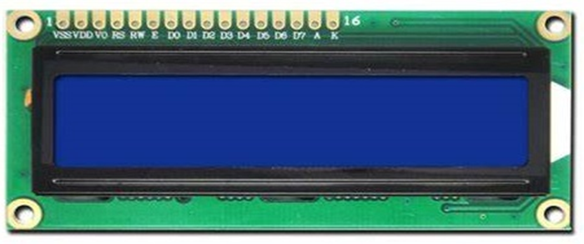

**Breadboard**

The breadboard is a construct consisting of positive and negative rows and columns, the main purpose of the board is to provide and easy connection of modules and components with the aim of eliminating the need for soldering. This will help provide an extension of the Arduino itself which is limited with a limited number of ports

**Figure 9.**

*Image of a Breadboard*

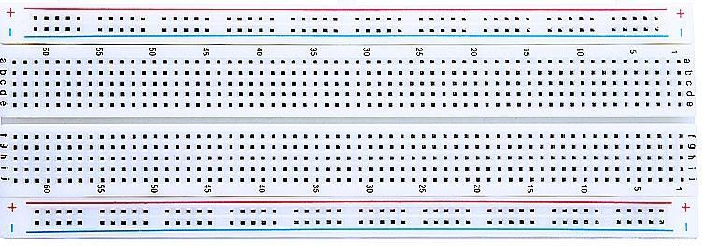

**Arduino Integrated Development Environment (IDE)**

To make communication with the arduino a development environment is required and hence the need for the IDE. The purpose of the IDE is to create programs that can then be uploaded to the arduino for execution. The C++ language will be used to write the appropriate scripts that are to be uploaded to the arduino and then executed as specified in the uploaded script.

**CSS and JavaScript**

CSS which is a cascading style sheet will be used in the creation of the interface, the CSS will be used for the overall appearance of the interface as it provides styling that is needed to make the interface more appealing to the end user. The JavaScript will be used to provide functionality to the interface in terms of what to display when an action is performed. In summary the JavaScript will be used to make the interface interactive to end user input or demands.

**C++ programming Language**

The language will be used for the coding that will take place within the arduino as it uses C++ scripts to interact with the modules connected to it. The main advantage of the C++ language over other programming languages for the arduino is that it can be used on embedded systems (Lospinoso, 2019).

## **Data Collection and Recording**

Data collection is a crucial aspect of research as it involves gathering and measuring information to answer research questions, evaluate outcomes, and test hypotheses (Paradis & Maria, 2018). In this study, data collection tools such as questionnaires and observations will be utilized. Questionnaires will be used to retrieve necessary information for the development of the system. This approach provides flexibility for participants to provide information at their convenience. Direct and indirect observations will also be conducted to ensure that the developed system accurately reflects real-world poultry monitoring practices.

To obtain a better understanding of participants' perspectives and practices, open-ended questions will be used during interviews. This approach will allow for insight into the thought processes of participants and provide feedback that can be used to improve the proposed system's implementation. To further aid in the understanding of poultry monitoring practices, case studies will be conducted alongside interviews. These approaches are aligned with the qualitative research methodology used in this study.

The data collection process will involve several steps to ensure that the data is accurate and reliable. The first step will involve gathering and organizing data collection forms and relevant materials. The second step will be to review and investigate the data to ensure that it is easily understood. The third step will focus on creating initial codes to aid in categorizing the data. The fourth step will involve modifying existing codes or classifying them into themes. The final step will involve organizing thoughts into a logical order that will effectively tell the data's story and best meet the study's aim.

In conclusion, this study will employ a qualitative research methodology to explore how lighting, temperature, and humidity affect poultry mortality rates. Data will be collected using a combination of questionnaires, observations, interviews, and case studies. The data will be analyzed using the narrative data analysis technique to identify recurring themes, languages, ideas, and beliefs. This study's findings will contribute to the development of more accurate and reliable automated poultry monitoring systems, ultimately leading to reduced mortality rates and improved egg production.

## **Validity and Reliability**

The qualitative research method will be employed for this study to examine the documented material in any form it may take, including text, media, and physical artifacts (Belotto, 2018). Specifically, the narrative data analysis technique will be utilized to focus on the experiences related to the implementation of an automated monitoring system for poultry lighting, temperature, and humidity. This technique will help to better understand what needs to be implemented and why it needs to be implemented, thereby making the proposed system more accurate and reliable. To ensure that the data is correct and reliable, several steps will be taken in the data analysis process. Firstly, data will be gathered and organized using data collection forms and other relevant materials. Secondly, the data will be reviewed and investigated to ensure a thorough understanding of the information collected. Thirdly, initial codes will be created to categorize the data collected. Fourthly, existing codes will be examined and modified, or classified into themes, to observe recurring themes, languages, ideas, and beliefs from the collected data. Lastly, the target audience, the study's aim, and the content that best tells the data's story will be considered to organize thoughts into a logical order.

## **Research Project Limitations**

Some of the requirements will be that the farmers have some kind of knowledge about systems and how they operate in order for them to effectively understand what is happening whenever they decide to log into the system to see what is happening. To help stop this from happening I will make the system as basic and simple as possible to navigate through. I will also ensure to have some suggestions for new users on how to interact with the system assuming it is their first time having an interaction with the system.

## **Delimitations**

In this research project secondary data will be utilized to test the system in order to achieve the main objectives set for the project. Therefore, for this project I will not go into the field to collect primary data, meaning administering questionnaires or conducting interviews will not be part of the research project. In addition, this project will not have a mobile application developed, it will only come with a web application that will be developed using open-source technologies to allow poultry farmers to have access to the system and check the environmental conditional parameters status

## **Ethical Considerations**

To ensure that there is ethical consideration, only small amounts of data will be required from the users of the system namely their preferred Identification Numbers and a password of their choice to log into the system and view the data from the sensors. Because the proposed system is a model only safe components will be used in the creation of the model so as to avoid any harmful outcomes from interactions with the system. To also ensure that there is trust of the system. Some of the data being read by the sensors will be displayed on the LCD so as to avoid the forced login of users into the system if they do not want to.

**Conclusion**

The methodology chapter has provided a comprehensive overview of the design aspects of the proposed smart monitoring system. It has identified prototyping as the software methodology that will be used in the development process, with the aim of ensuring that the system is developed in line with the project objectives and within the specified timeline. The chapter has also outlined the functional and non-functional requirements of the system, as well as the hardware components, open-source software, and programming languages that will be used in the implementation phase. The use of object-oriented tools, such as use case and flowchart diagrams, has been used to provide readers with a clear understanding of the system's functionality. In addition, the chapter has also discussed ethical considerations that will guide the researcher during the implementation process. Overall, this chapter has laid the groundwork forth the successful development of the proposed smart management system module.

## **References**

Ayhan, O. (2020). Sampling Methods in Research Methodology; How to Choose a Sampling Technique for Research. *International Journal of Academic Research in Management (IJARM) Vol. 5, No. 2*, 18 - 21.

Belotto, M. (2018). Data Analysis Methods for Qualitative Research: Managing the Challenges of Coding, Interrater Reliability, and Thematic Analysis. *Qualitative Research Graduate Certificate Indulge in Culture*, 2622 - 2624.

Canals, L. (2020). Instruments for gathering data. 390 - 391.

D, A. M., & Manohar, S. (2021). IOT Based Smart Poultry Farming. *Journal of Engineering & Management Volume 5, No 2*, 1 - 2.

Farrell, D. (2017). poultry housing and management in developing countries. *school of veterinary science*, 24-28.

Karim, N. S., Mohamed, T. B., & Nordin, U. A. (2019). Urbanized Chicken Coop Monitoring System using IoT. *International Journal of Advanced Trends in Computer Science and Engineering*, 450.

Kolln, A.-K., Ongena, p. Y., & Kees, A. (2019). The Effects of Sampling Frame Design on Nonresponse and Coverage Error: Evidence from the Netherlands. *Journal of Survey Statistics and Methodology, Volume 7, Issue 3*, 422-439.

Novida, S., Aritonang, R., & Sumarlin. (2021). Smart Chicken Coop Control and Monitoring System Design Automatically with Smartphone Notifications. *Research of Artificial Intelligence*, 38-41.

Oloyo, A., & Adedamola, O. (2019). Poultry Housing and Management. 1-12.

Oloyo, A., & Adedamola, O. (2019). Poultry Housing and Management. *International journal of advanced sciences and agriculture*, 1-3.

Orakwue, S. I., Al-Khafiji, H. M., & Chabuk, M. Z. (2021). IoT Based Smart Monitoring System for Efficient Poultry Farming. 4105 - 4106.

Pace, D. D. (2021). PROBABILITY AND NON-PROBABILITY SAMPLING - AN ENTRY POINT FOR UNDERGRADUATE RESEARCHERS. *International Journal of*

Pandey, S. C. (2019). Case Study Research. *Methodological Issues in Management Research: Advances, Challenges and the Way Ahead*, 163-165.

Paputungan, I. V. (2020). Temperature and Humidity Monitoring System in Broiler Poultry Farm. *International Conference on Information Technology and Digital Applications*, 1 - 7.

Paradis, E., & Maria, T. M. (2018). Design: Selection of Data Collection Methods. *Journal of Graduate Medical Education*, 1-3.

Putra, R. A., Estananto, & Ketut, A. E. (2021). Automatic Temperature Control System on Smart Poultry Farm Using PID Method. *International Journal of Green Intelligent Systems and Applications*, 34-42.

*Quantitative and Qualitative Research Methods Vol.9, No.2, pp.1-15, 2021*, 1-4.

Rahman, M. S. (2017). The Advantages and Disadvantages of Using Qualitative and Quantitative Approaches and Methods in Language “Testing and Assessment” Research: A Literature Review. *Journal of Education and Learning; Vol. 6, No. 1*, 102.

Stamp, M., & Dawkins, E. R. (2020). Poultry Welfare monitoring: group-level technologies. 1-4.

Ünver, C., Küçükyılmaz, O., & Konca, Y. (2019). The Effect of Different Lighting Programs on Performance, Carcass and Egg Quality Characteristics in Laying Hens. Journal of Applied Poultry Research, 28(4), 1161-1168.<https://doi.org/10.3382/japr/pfz046>

Xie, H., & Hou, S. (2019). Real-time monitoring system of chicken house environment parameters based on wireless sensor network. 2019 IEEE 4th International Conference on Cloud Computing and Big Data Analysis (ICCCBDA), Chengdu, China, pp. 95-98.

Al-Rowaily, M., Aldosari, F., & Altamimi, A. (2021). Precision Poultry Farming: A New Trend to Improve Production, Welfare, and Sustainability of Poultry Production. Sustainability, 13(2), 567.<https://doi.org/10.3390/su13020567>

Mishra, S. K., & Park, S. H. (2021). Automated poultry monitoring system: design, implementation, and performance evaluation. Computers and Electronics in Agriculture, 184, 106016.<https://doi.org/10.1016/j.compag.2020.106016>

Igbafe, O. &. (2018). An Overview of Internet of Things (IoT) and Data Analytics in Agriculture: Benefits and Challenges. *n.d.*, n.d.

Niranjan, D. (2018). Wireless Sensor Networks. *International Journal of Engineering Research & Technology*, N.D.

Gonzalez-Rios, H., & Rayas-Amor, A. A. (2021). Monitoring of poultry growth and welfare through the use of sensors: A review. Journal of animal science and technology, 63(4), 1081-1094. doi: 10.5187/jast. 2021.e82

Wixom, A. D. (2017). *Systems Analysis and Design* (6 ed.). Boston: John Wiley & Sons, Inc.

Blouin, E. (2020, July 29). Arduino UNO: A Low-cost and Flexible Programmable Open-source Microcontroller Board. n.d.

Priya, M. (2021, May). Smart Poultry Farm Incorporating GSM and IOT. n.d.

Sandilands, V., et al. "The effect of lighting provision on the welfare of laying hens in non-cage systems: a review." Animal Welfare 28.3 (2019): 253-267.

Mench, Joy A. "Broiler breeders: Feed restriction and welfare." World's Poultry Science Journal 76.2 (2020): 283-296.

Chiang, Wen‐Chieh, et al. "Effects of photoperiods and light intensity on growth performance, physiological responses, and carcass traits in male broilers." Poultry science 99.10 (2020): 5048-5057.

Wang, Jun, et al. "Effects of light intensity on laying performance, egg quality, and bone metabolism in white leghorn laying hens." Poultry Science 99.7 (2020): 3539-3547.

Lichovnikova, Martina, et al. "Artificial light in poultry production: A review." Animals 10.7 (2020): 1199.

Xie, Xian-Hui, et al. "Influence of light-emitting diode lights on laying performance, egg quality, and oxidative status of laying hens." Poultry Science 99.2 (2020): 964-970.

Creswell, J. W. (2014). Research design: qualitative, quantitative, and mixed methods approaches. Sage publications.

Davis, F. D. (1989). Perceived usefulness, perceived ease of use, and user acceptance of information technology. MIS quarterly, 319-340.

Mishra, P., & Behl, J. R. (2019). Effect of Feeding Schedule on Mortality and Performance of Broilers. International Journal of Livestock Research, 9(4), 74-79.

Olanrewaju, H. A., Miller, W. W., Maslin, W. R., & Collier, S. D. (2019). Automation of Poultry Production: A Review. Journal of Applied Poultry Research, 28(3), 635-648.

Chauhan, A., Sharma, A., & Singh, N. (2015). Poultry Management Practices and their Influence on Mortality of Broilers in India. International Journal of Livestock Research, 5(6), 42-47.

Elwinger, K., & Tauson, R. (1997). Comparison of nipple and bowl feeding of laying hens. Acta Agriculturae Scandinavica, Section A-Animal Science, 47(3), 160-167.

Kitalyi, A. (1998). Village chicken production systems in rural Africa: Household food security and gender issues. FAO Animal Production and Health Paper, 142.

Alim, M. A., Islam, M. A., Mondal, M. M. H., & Rahman, M. M. (2019). Effect of Different Feeding Management Practices on the Performance and Economics of Broiler Farming in Bangladesh. Journal of Agricultural Science and Technology, 21(2), 313-323.

Cao, X., Wang, J., Zhou, L., Liu, Z., & Zhang, Y. (2020). Effects of different feeding systems on growth performance, nutrient utilization, and immunity of broilers. Poultry Science, 99(11), 5319-5328.

Kozlowski, K., El-Sabrout, K., Garlich, J. D., & Austic, R. E. (2021). Automated Feeding Systems for Laying Hens: Effects on Production Performance and Mortality. Poultry Science, 100(1), 100935.

Aruna, B. P., Kumar, P., Reddy, D. K., & Rajasekhar, K. (2019). Effect of manual and automated feeding systems on growth and mortality of broiler chickens. Journal of Entomology and Zoology Studies, 7(2), 150-155. Ganaie, A. H., Wani, G. M., & Dar, M. A. (2020). Effect of manual and automatic feeding system on the growth and mortality of broiler chickens. International Journal of Livestock Research, 10(10), 43-48. Havenstein, G. B., Ferket, P. R., & Qureshi, M. A. (2020). Growth, efficiency, and yield of commercial broilers from 1957, 1978, and 2005. Poultry Science, 99(9), 4392-4398. Lilburn, M. S. (2019). Poultry feeding systems. In Handbook of Poultry Science and Technology (pp. 213-227). John

Lilburn, M. S. (2019). Poultry feeding systems. In Handbook of Poultry Science and Technology (pp. 213-227). John Wiley & Sons, Inc

Ilo, S., & Akinola, A. (2021). Evaluation of an Automated Poultry Feeder in Small-Scale Poultry Farming. International Journal of Poultry Science, 20(1), 30-37.

Bhattarai, S., & Zhao, Y. (2019). Development of a smart feeding system for poultry industry. Sensors, 19(19), 4224. doi: 10.3390/s19194224

Nakyinsige, K., & Halidou, I. (2020). Economic Feasibility of Automated Poultry Production: A Review. International Journal of Agriculture and Biology, 26(2), 305-310. <https://doi.org/10.17957/IJAB/15.1286>